3.58: Equation 3.27 relates the vertical and horizontal components of position for a given set of initial values.
a) Solving for  gives
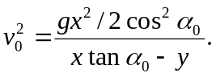
Insertion of numerical values gives 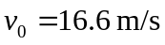.
b) Eliminating t between Equations 3.20 and 3.23 gives 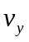 as a function of ,
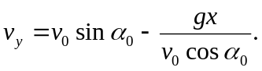
Using the given values yields so 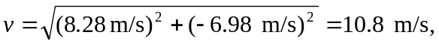 at an angle of 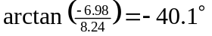, with the negative sign indicating a direction below the horizontal.
c) The graph of 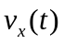 is a horizontal line.
